PERSONNEL INFORMATION FORM
NOTE:
- PLEASE FILL ALL THE RELEVANT DETAILS WITH CORRECT SPELLING & AVOID OVERWRITING
- THIS FORM WILL REMAIN THE SOLE PROPERTY OF ASPIRE SYSTEMS( INDIA) PRIVATE LIMITED

Contact Details Form
Date of joining |  | 22nd October 2020
Full Name ( as in records) |  | Priyadharshini S
Middle Name |  | -
Surname |  | -
Father's Name (with initials) |  | Sugavanam S
Date of Birth (DD/MM/YYYY) |  | 02/06/1999
Gender |  | Male: |  |  |  |  | Female:Yes
Blood Group |  | A1+ |  | Bank A/c No:611901551184 |  |  |  |  | Name as per Bank Records:S Priyadharshini
Nationality |  | Indian |  | IFSC Code & Branch:ICIC0006119 |  |  |  |  | Bank Name: ICICI
Contact Details
Address |  | Permanent Address |  |  |  |  |  | Present Address (Local)
 |  | 342/140,Arjuna nagar, Alagapuram ,Periyapudur  Salem-636016 |  |  |  |  |  | 342/140,Arjuna nagar, Alagapuram ,Periyapudur  Salem-636016
Contact Number of Employee |  | Landline: - |  |  |  |  |  | Landline : -
 |  | Primary Mobile No:7397088188 |  |  |  |  |  | Alternative Mobile No:9965580975
Personal Email ID |  | priyadharshinisugavanam@gmail.com |  |  |  |  |  | Birth Place |  | Salem
Emergency Contact Name & Relationship |  | Sugavanam & Father |  |  |  |  |  | Emergency  Number |  | 9965580975
Passport No. |  | - |  |  |  |  |  | Valid up to (DD/MM/YYYY) |  | -
PAN No & Name as per Pan card(Mandatory) |  | DDNPP8672N & PRIYADHARSHINI S
UAN No (Mandatory) |  | New UAN
Adhaar Card No:  Name as per Adhaar card:  DOB as per Adhaar card: |  | 342/140,Arjuna nagar, Alagapuram ,Periyapudur  Salem-636016
 |  | S Priyadharshini
 |  | 02/06/1999
Academic Credentials
 | Degree with Discipline |  | School/College ,Location |  |  |  | University/ Board |  |  | Year of Study From -TO | %/Grade
Post Graduation | - |  | - |  |  |  | - |  |  | - | -
Under Graduation | BE-ECE |  | K.S.R College of Engineering,Tiruchengode |  |  |  | Autonomous(Anna University) |  |  | 2016-2020 | 8.734
Higher Secondary | HSC-Computer science |  | Holy angels Matriculation Higher Secondary School,Salem |  |  |  | State Board |  |  | 2015-2016 | 87
Secondary | SSLC |  | Sri Sarada Matriculation Higher Secondary School,Salem |  |  |  | State Board |  |  | 2013-2014 | 94
Any other Qualifications | - |  | - |  |  |  | - |  |  | - | -
Certifications, if any | -
Family Details – For Married Employees

Wedding Anniversary
(DD/MM/YYYY)
 | Name |  |  |  |  | Date of Birth (DD/MM/YYYY)
Spouse
Daughter/Son
Daughter/Son
Work Experience
Name of the Organisation  (Name As mentioned on the Letter Head) | Dates ( From – To )  (DD/MM/YYYY) |  |  |  | Designation | Role/ Responsibility |  |  |  | Last Salary  Drawn  (Monthly Gross) | Period (MONTHS)
1
2
3
4

Priyadharshini.S 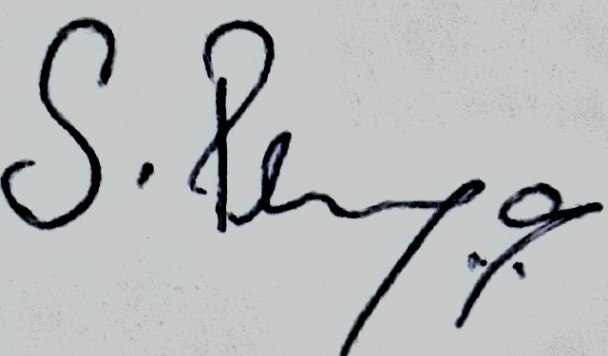

NAME SIGNATURE

